» Privacy Policy - Least Data Collection
Privacy Policy
When you visit or view [this site], the site collects no personally identifiable information about you.
A cookie is set that expires at the end of the session. Server logs are maintained to protect the security of the site and to help improve the site by analyzing aggregate data. Logs are purged [on a schedule determined by site owner].
If you submit a comment on a post, you will be asked to provide an email address. Whether you choose to provide an accurate one is up to you.
[If applicable] Because this site uses a WordPress platform, the IP address you connected from will be stored with your comment, even though it will not appear on the site. This site accepts proxied connections.
The site may disclose data when required to by law, in response to a subpoena, or if served with a search warrant. The site also may voluntarily disclose data about site activities to the site hosting company or others in connection with the operation, maintenance, and security of the site.
If you send an email threatening legal action, your email may be published on the site, any confidentiality signature files in your email notwithstanding. By emailing [site owner], you accept [site owner’s] terms.
This site is not responsible for the privacy policies of any sites it may link to. Read their privacy policies.
Questions about this privacy policy? Contact [site owner].

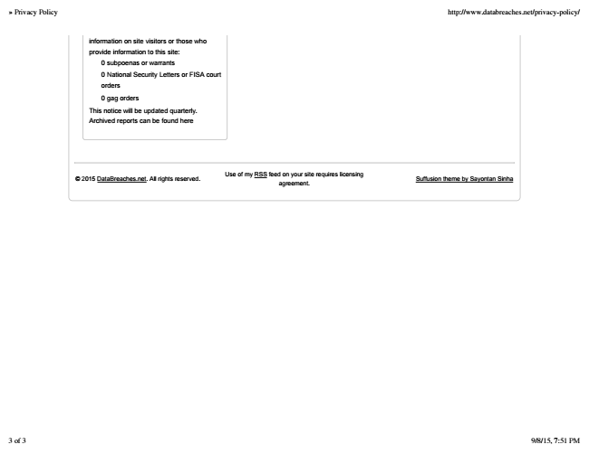

» Privacy Policy http://www.databreaches.net/privacy-policy/
information on site visitors or those who provide information to this site:
0 subpoenas or warrants
0 National Security Letters or FISA court orders
0 gag orders
This notice will be updated quarterly. Archived reports can be found here
© 2015 DataBreaches.net. All rights reserved.
Use of my RSS feed on your site requires licensing agreement.
Suffusion theme by Sayontan Sinha
3 of 3 9/8/15, 7:51 PM

